**CAPE GIRARDEAU COUNTY PUBLIC HEALTH CENTER**

**2012**

**COMMUNITY HEALTH ANALYSIS**

**INTRODUCTION:** Every three years, the Health Center conducts an assessment of health status indicators, fulfilling one of the Core Public Health Functions. The previous Community Health Assessment reviewed data from 2006 / 2007 / 2008 and was compiled in 2009. The 2012 Community Health Assessment reviews data from 2009 / 2012/ and 2011 when available. It also provides a comparison to the previous assessment per indicator when indicated.

Data from several different sources was analyzed, including but not limited to: Missouri Department of Health and Senior Services, Missouri Department of Social Services, Missouri Department of Education, [www.cassas.org](http://www.cassas.org), [www.missourieconomy.org](http://www.missourieconomy.org), US Census, EPA, Missouri Department of Public Safety.

Data was also reviewed from a nine county Regional Assessment conducted by East Missouri Action Agency for the counties of Bollinger, Cape Girardeau, Iron, Madison, Perry, Reynolds, St. Genevieve, St. Francois, and Washington. When available local data was also used for comparisons.

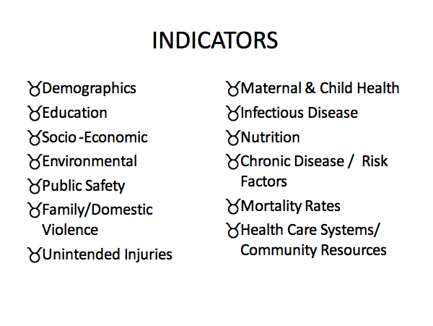

**SUMMARY OF SIGNIFICANT FINDINGS**

* Significant Larger Senior Population
* Increasing Hispanic / Latino Population
* Increased Risk of Smoking in County / Higher rate of Smoking During Pregnancy
* Juvenile Law Violation Rates higher than the state
* Higher Rates of Death due to:
  + Heart Disease, Stroke, Alzheimer’s
* Women 18 and Older Not Seeking Pap Test as Recommended
* Higher Rates of Overweight / Obesity / Physical Inactivity

Diabetes Risk Factors

* Immunization Rates Lower than the state rates for 2 year olds

**PUBLIC HEALTH PRIORITIES**

Health Center staff have identified the three most significant problems affecting the health status of the population:

1. **Obesity Rate**
2. **Increased rate of Smoking in County / Higher Rate of Smoking During Pregnancy**
3. **Immunization Rates**